Circles of My Multicultural Self
This activity highlights the multiple dimensions of our identities. It addresses the importance of individuals self-defining their identities and challenging stereotypes.
Place your name in the center circle of the structure below. Write an important aspect of your identity in each of the satellite circles -- an identifier or descriptor that you feel is important in defining you. This can include anything: Asian American, female, mother, athlete, educator, Taoist, scientist, or any descriptor with which you identify.
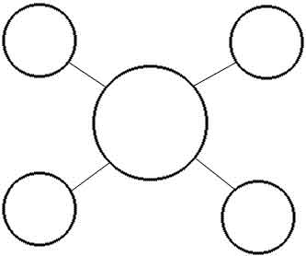
1. Share a story about a time you were especially proud to identify yourself with one of the descriptors you used above.
2. Share a story about a time it was especially painful to be identified with one of your identifiers or descriptors.
3. Name a stereotype associated with one of the groups with which you identify that is not consistent with who you are. Fill in the following sentence:
I am (a/an) _____________________ but I am NOT (a/an)_____________________.
(So if one of my identifiers was "Christian," and I thought a stereotype was that all Christians are radical right Republicans, my sentence would be:
I am a Christian, but I am NOT a radical right Republican.

